**Exercise 1: Configuring a Basic Spring Application**

**Step 1: Set Up a Maven Project**

* Creating a Maven-based Java project named LibraryManagement.
* Adding necessary Spring Core dependencies in pom.xml.
* **Instructions:**

1. Open your IDE (e.g., IntelliJ, Eclipse).
2. Create a new Maven project: LibraryManagement
3. Add Spring dependencies in pom.xml

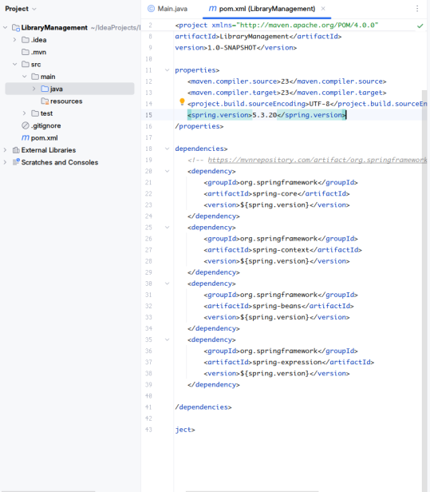

**Step 2: Configure the Application Context**

* Creating an XML configuration file that defines beans (services and repositories).
* This file is used by Spring to manage your components.
* **Instructions:**

1. Inside src/main/resources, create a file: applicationContext.xml
2. Add the configuration

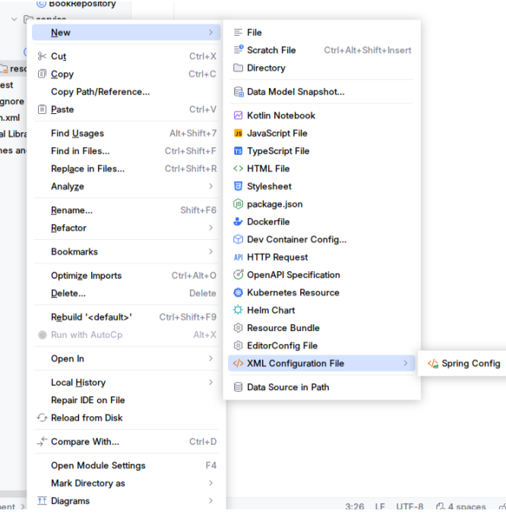

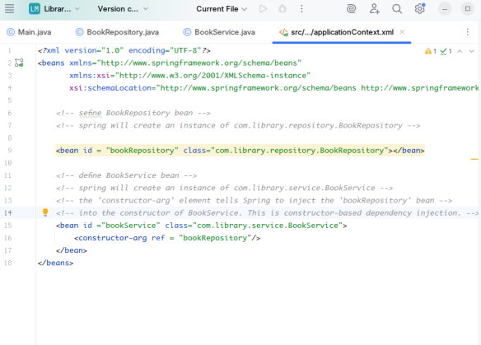

**Step 3: Create Service and Repository Classes**

* Defining the logic layers as POJOs (Plain Old Java Objects).
* BookService depends on BookRepository (injected by Spring).
* **Instructions:**

1. Create package: com.library.repository
2. Create package: com.library.service

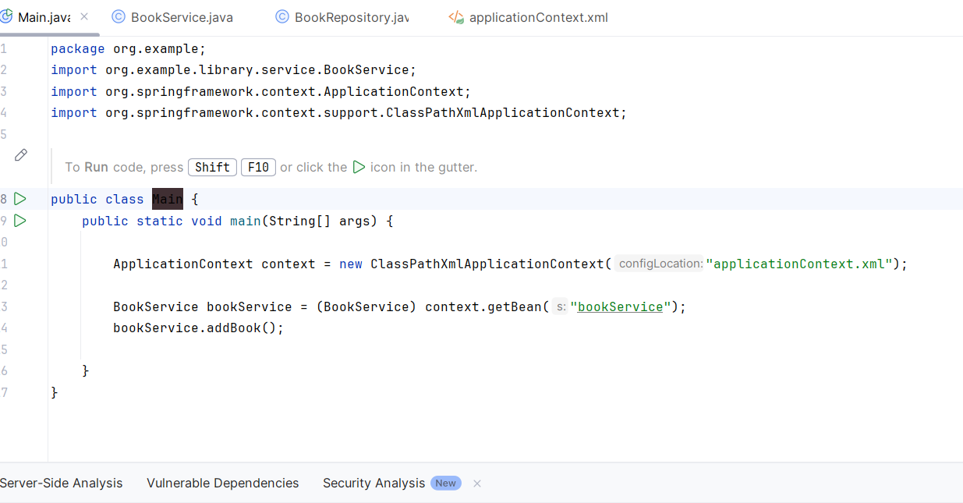

**Step 4: Run the Application**

* Loading the Spring context from the XML file.
* Fetching bookService bean and calling its method.
* **Instructions:**

1. Create a main class in com.library
2. Run the main class.